Introduction

I create projects of CRUD (Create, Read, Update, and Delete) operations in ASP.NET Core MVC (.Net 6.0) with code first migration. We will use Entity Framework Core 6 to interact with the SQL Server database. I use here two Entity for CRUD operation (Category and Product).

**Cover the following points.**

* Create ASP.NET Core MVC 6.0 project in visual studio 2022
* Install all the necessary packages from NuGet.
* Create entities in the Model folder.
* Create BaseEntitie in the Model folder.
* Crete ApplicationDbContext class to interact with Database in Data folder
* Add connection string of SQL Server database into appsettings.json file
* Run migration commands inside Package Manager Console (PMC)
  + Add-Migration "Initial"
  + Update-Database
* Add controllers inside the controller folder
* Add view models in Model folder
* Add DataContext in Data folder
* Add Repository and IRepository in in Repository folder
* Add Views and partial views
* Add Validation
* Updated Bootstrap and Added bootstrap Js and css file online link

**Prerequisites**

* Visual Studio 2022 (.Net 6.0)
* SQL Server

**Step 1**. Create ASP.NET Core MVC 6 project

First, open Visual Studio 2022 and click on**"Create a New Project" (**highlighted in green colour circle**)**

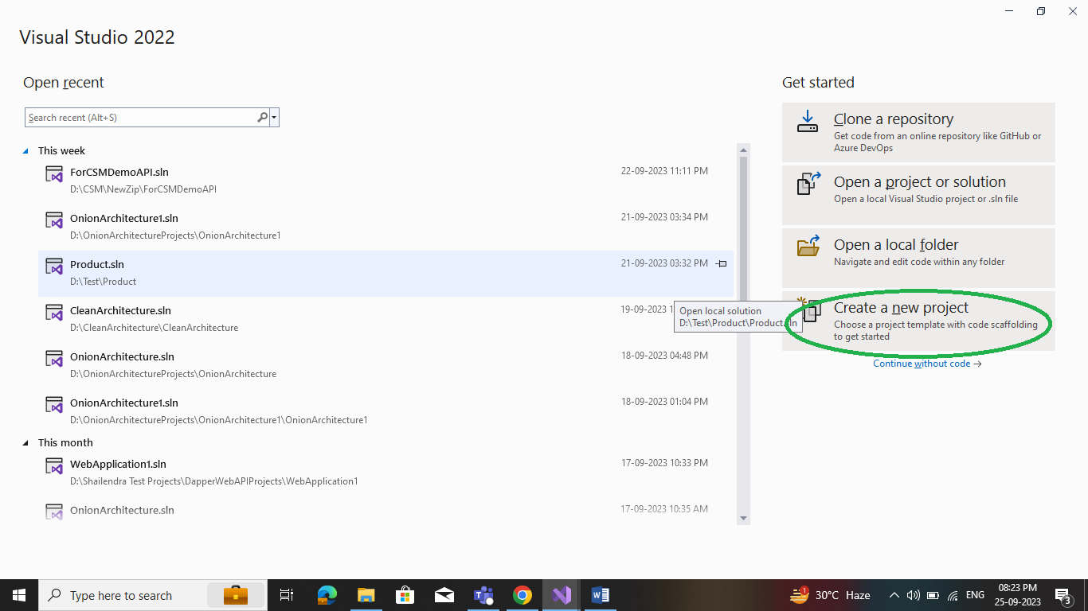

Search "**MVC**" in the Search box**(Search for templates (Alt+s))**and select**ASP.NET Core Web App (Model-View-Controller)**as a project template and click**the Next**button**.**

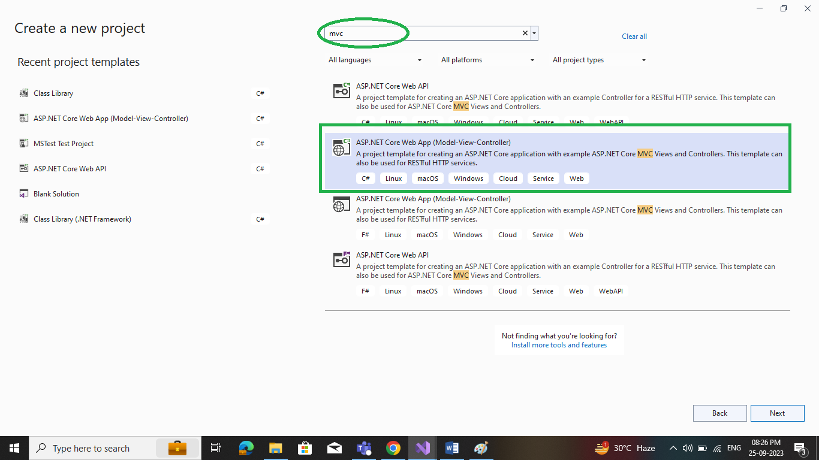

Enter a project name and click next.

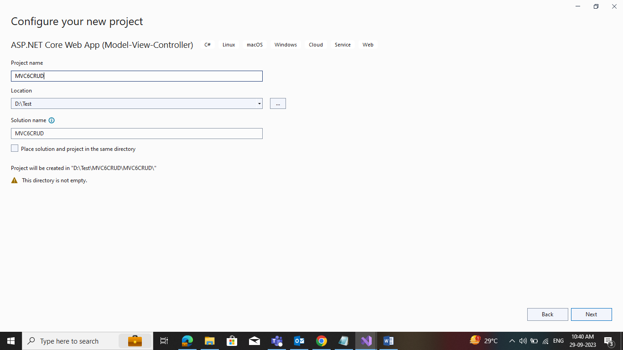

Go with the basic configuration as per the below screen; click**Next.**

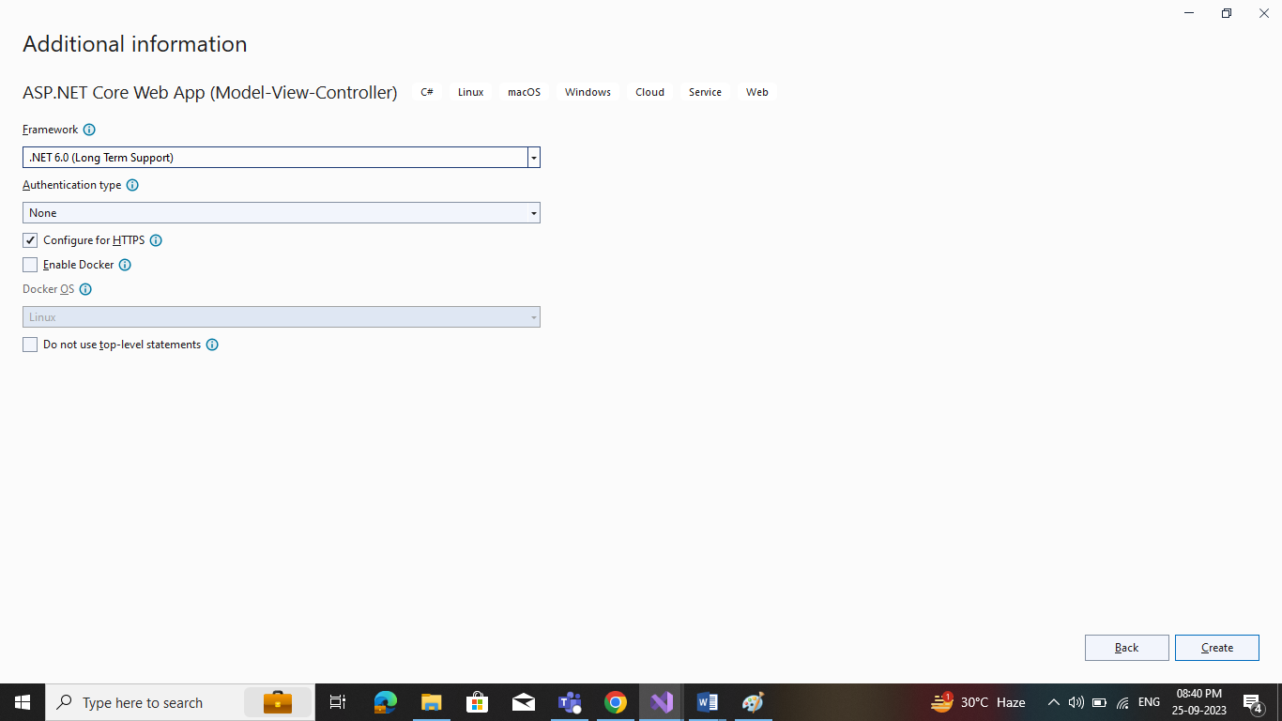

**ASP.NET Core MVC (.Net 6.0) project structure**

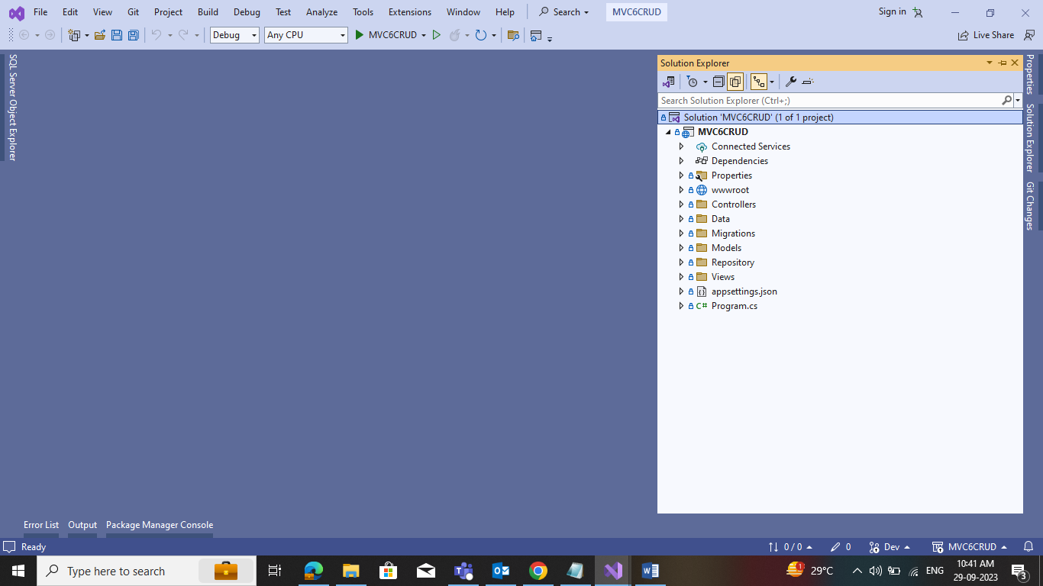

**Step 2**. Install the required package from NuGet

Required package for ASP.NET Core MVC (.Net 6.0) CRUD operation application

* Microsoft.EntityFrameworkCore
* Microsoft.EntityFrameworkCore.SqlServer
* Microsoft.EntityFrameworkCore.Tools

Now, we install the above package one by one**.**Right-click on**Dependencies**and select**"Manage NuGet Packages…"**

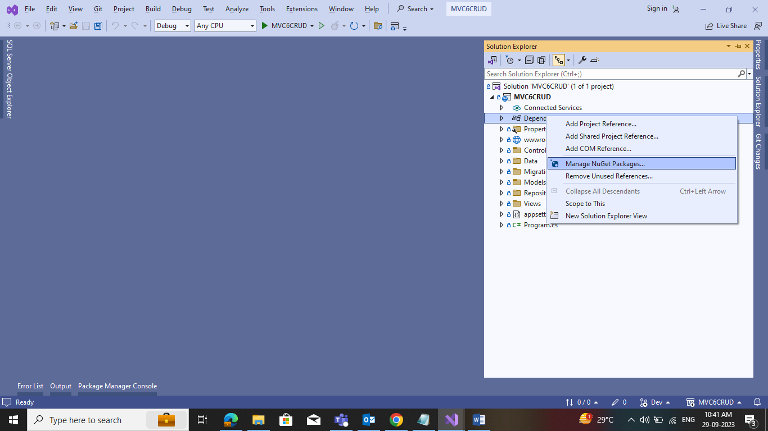

Install **Microsoft.EntityFrameworkCore**package**.**

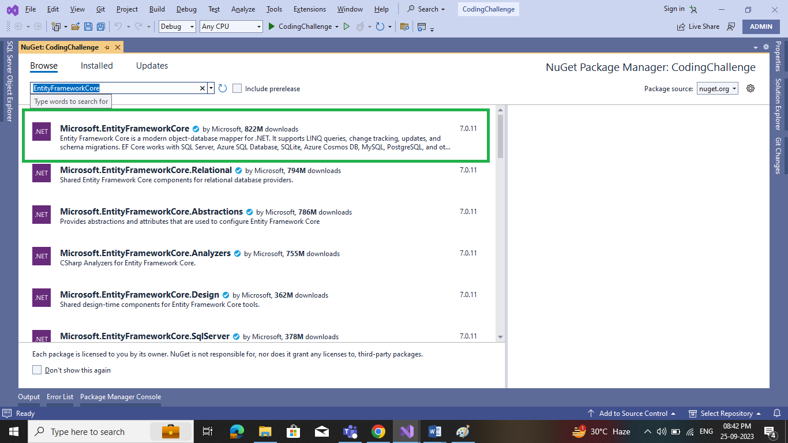

Install **Microsoft.EntityFrameworkCore.SqlServer**package**.**

Install **Microsoft.EntityFrameworkCore.Tools**package**.**

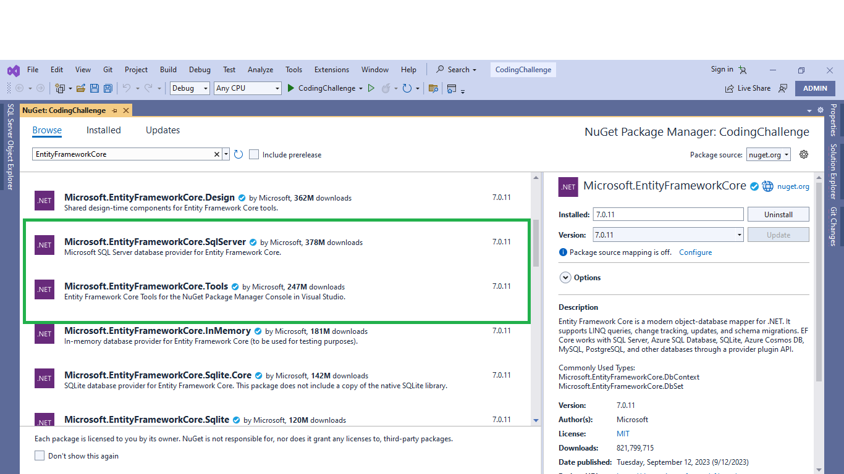

All install packages are showing in **Dependencies -> Packages**

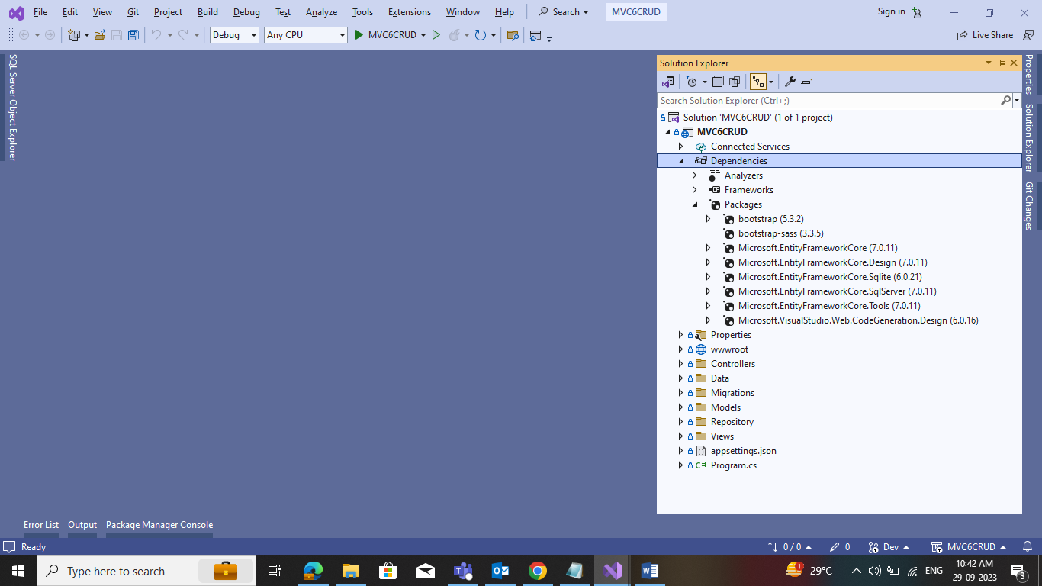

**Step 3**. Add **BaseEntity** entities class into the **Model** folder

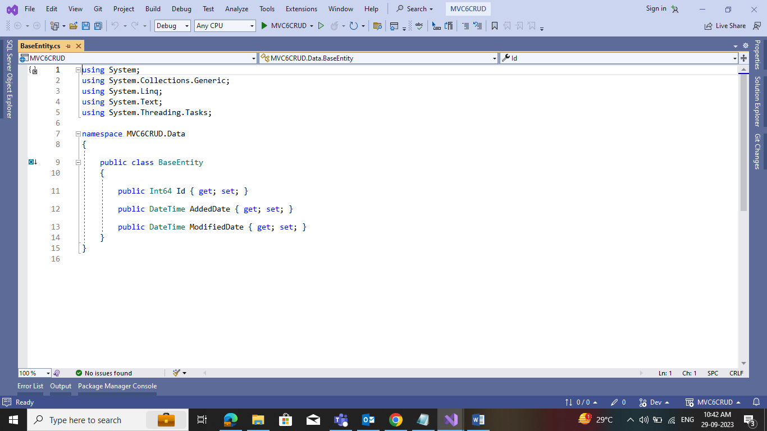

**Step 4**. Add **Category** and **Product** entities class into the **Model** folder and inherit from BaseEntity

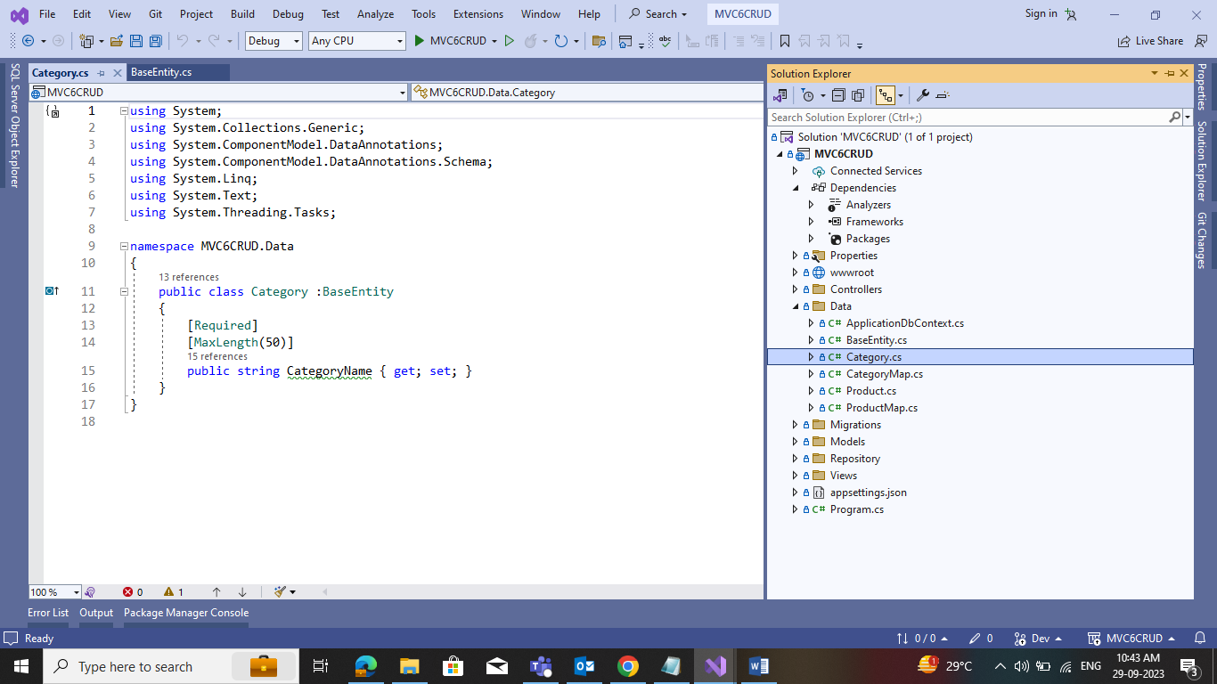

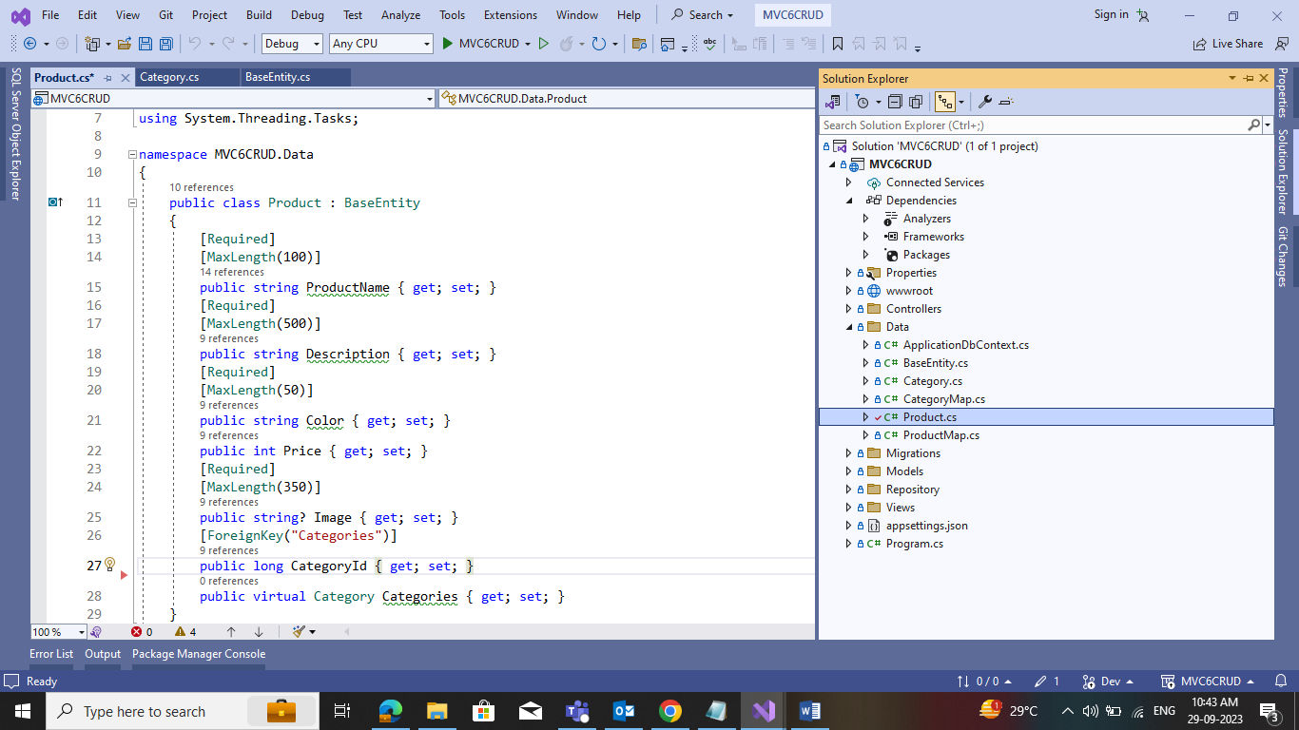

**Step 5.**Add **ApplicationDbContext**class inside the **Data** folder and inherit it to DbConext

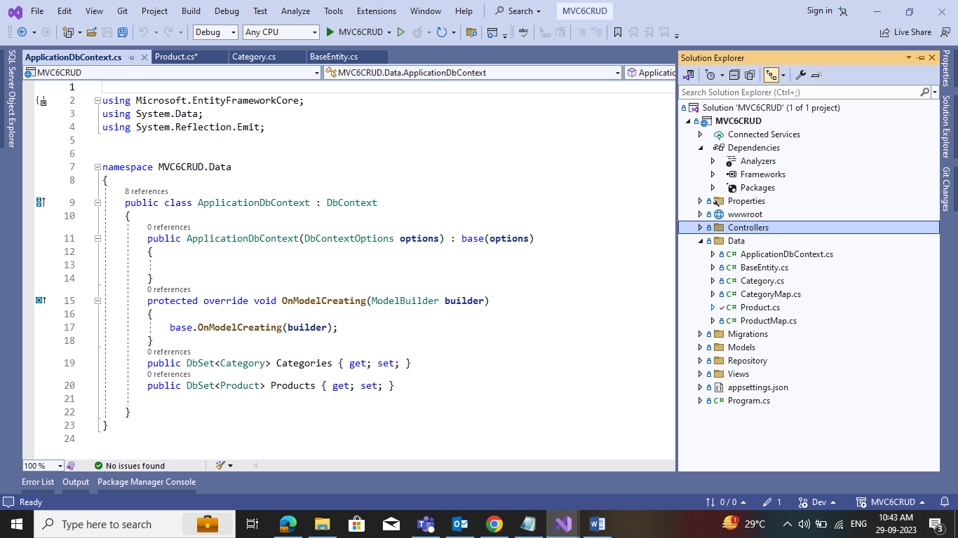

**Step 6.**Add **Connectionstring** into **appsettings.json**

"ConnectionStrings": {

"CodingChallengeConnection": "Data Source=(localdb)\\mssqllocaldb;Database= ProductCategoryDB;Integrated Security=True;MultipleActiveResultSets=true;"

}

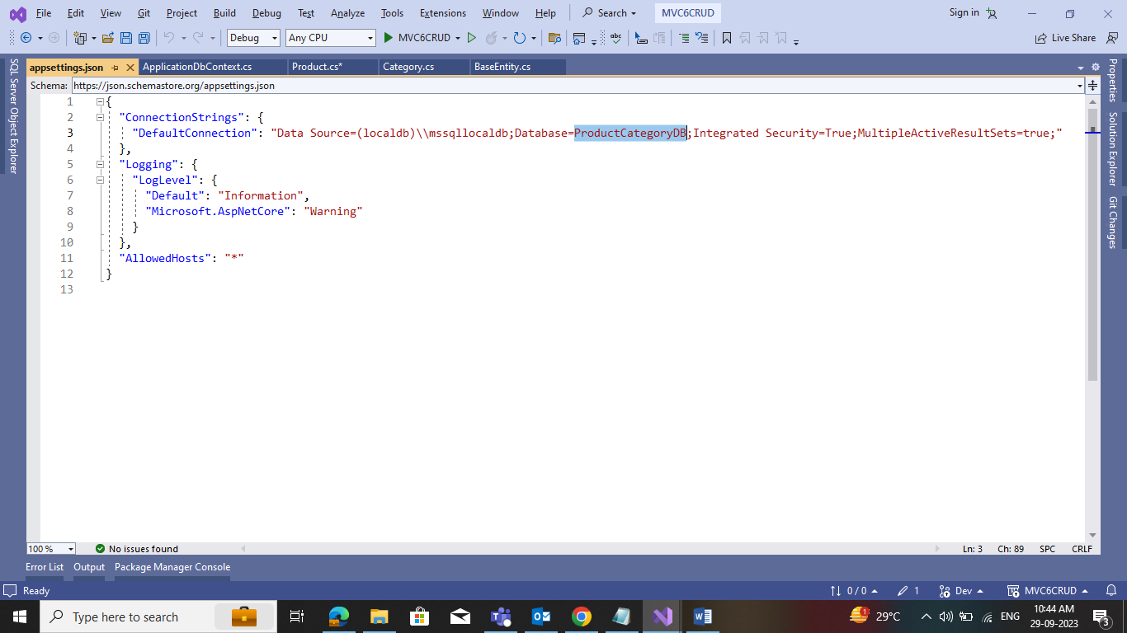

**Step 7.** Add DbContext Service into Program.cs file with the connection string

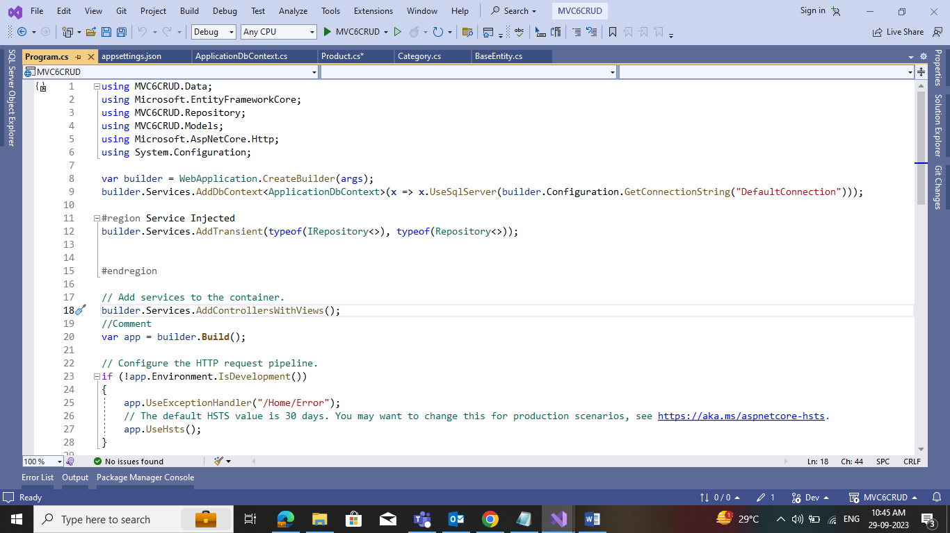

**Build solution**

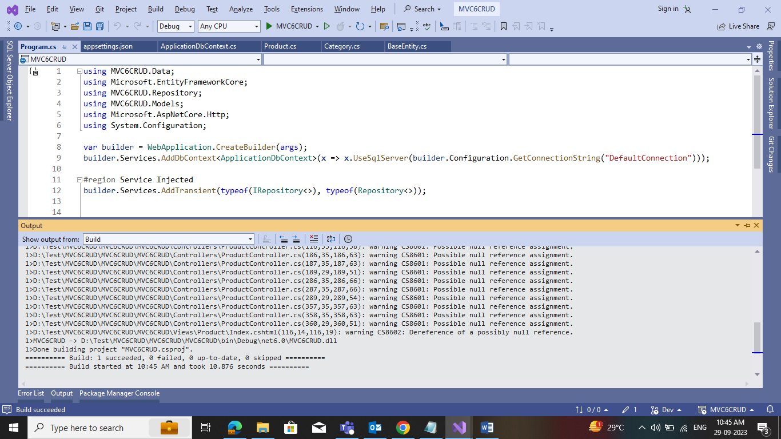

**Step 8.** Run migration commands inside Package Manager Console (PMC) to create a Database

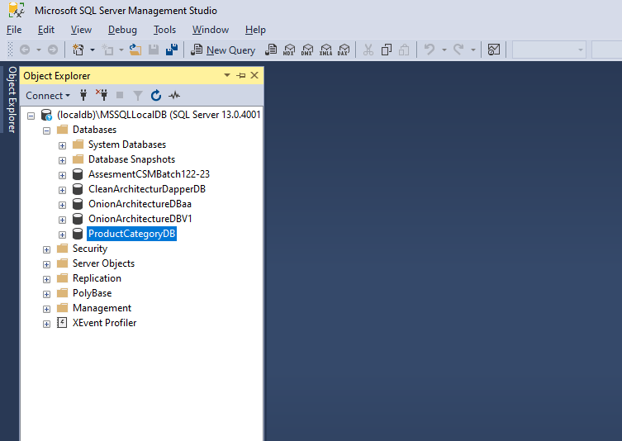

**Package Manager Console (PMC)**

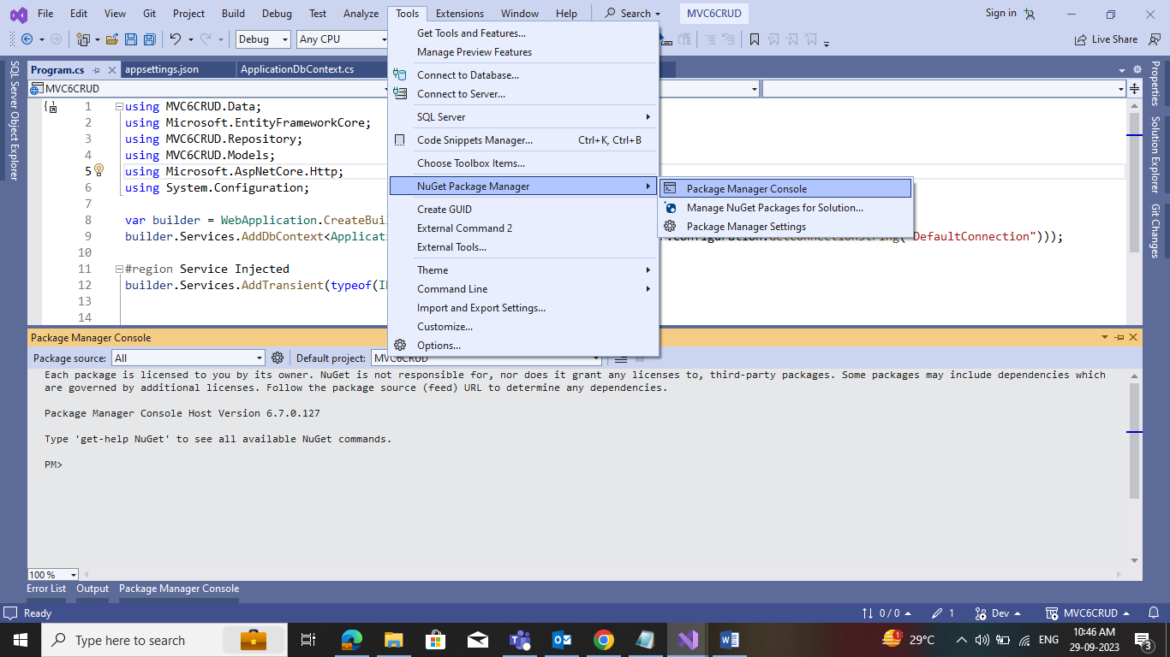

**Add-Migration "Initial" command**

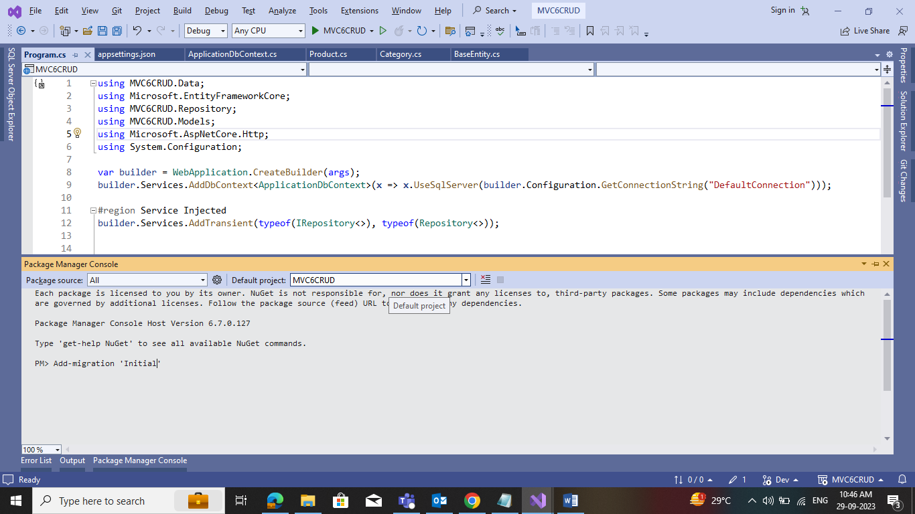

Update-Database command

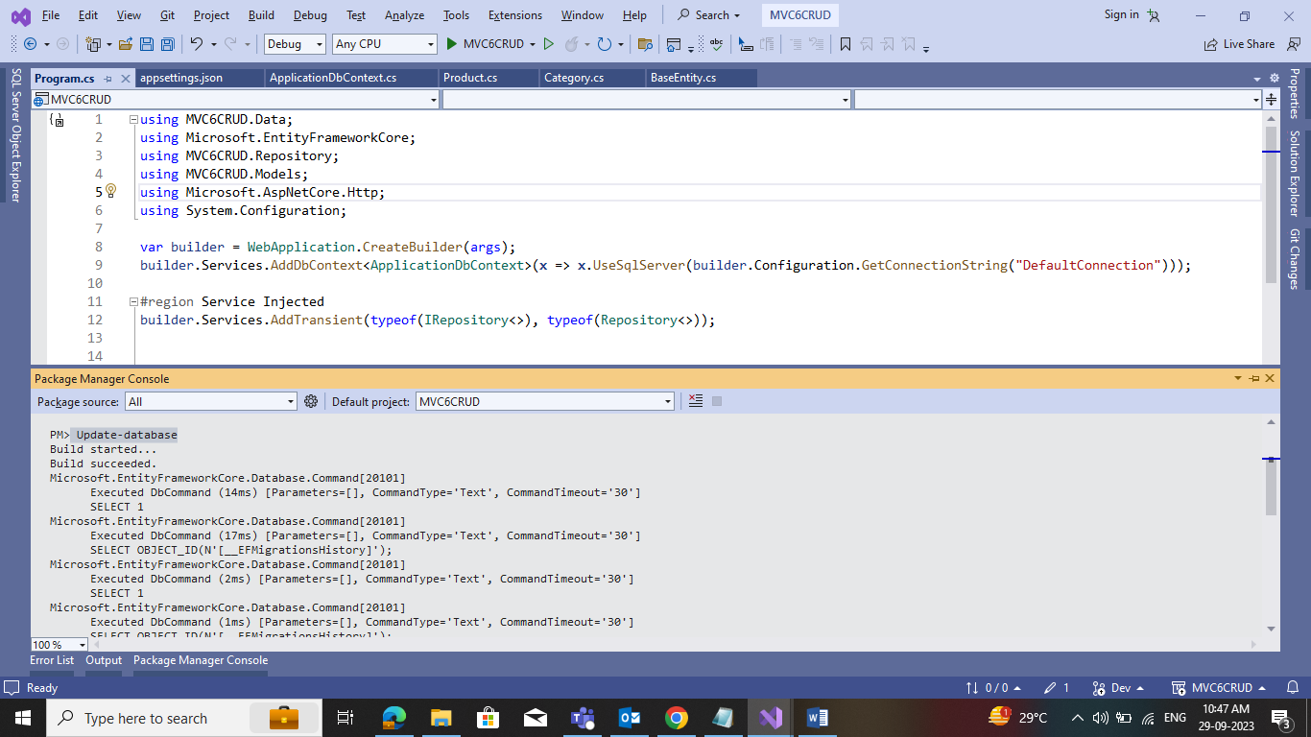

ProductCategoryDB created into SQL Server with Categories and Products table.

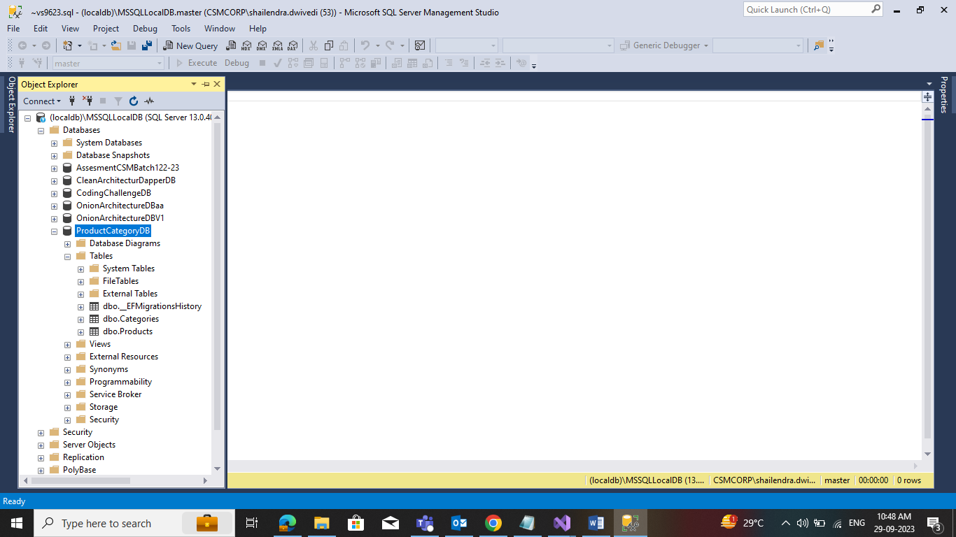

**Step 9**. Add Repository and IRepository in Repository folder

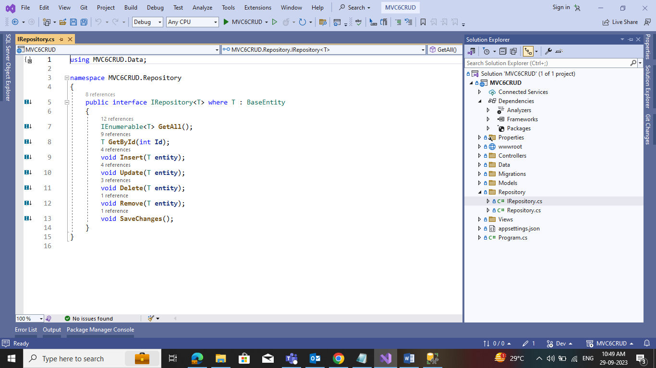

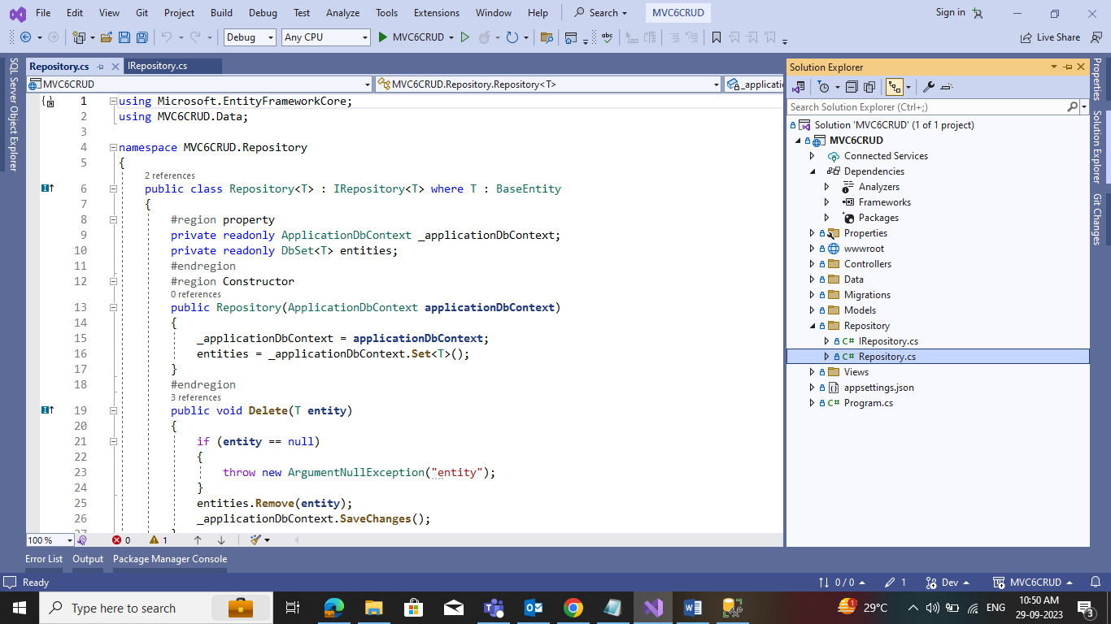

After Repository created the add service references in Program.cs

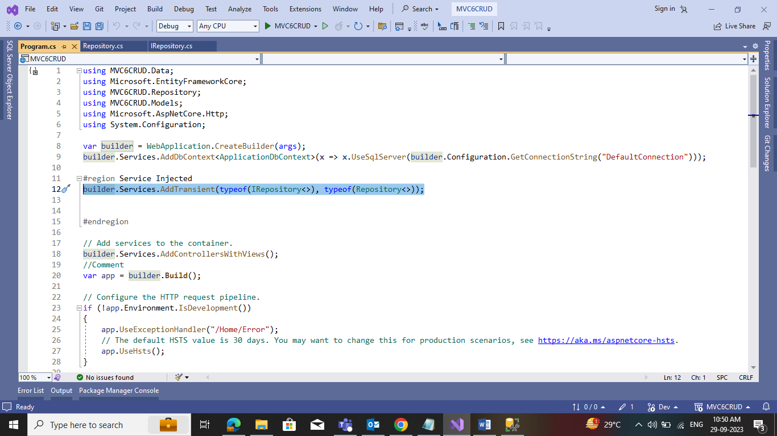

**Step 10.**Add the Category controller and Product controller in the controller folder

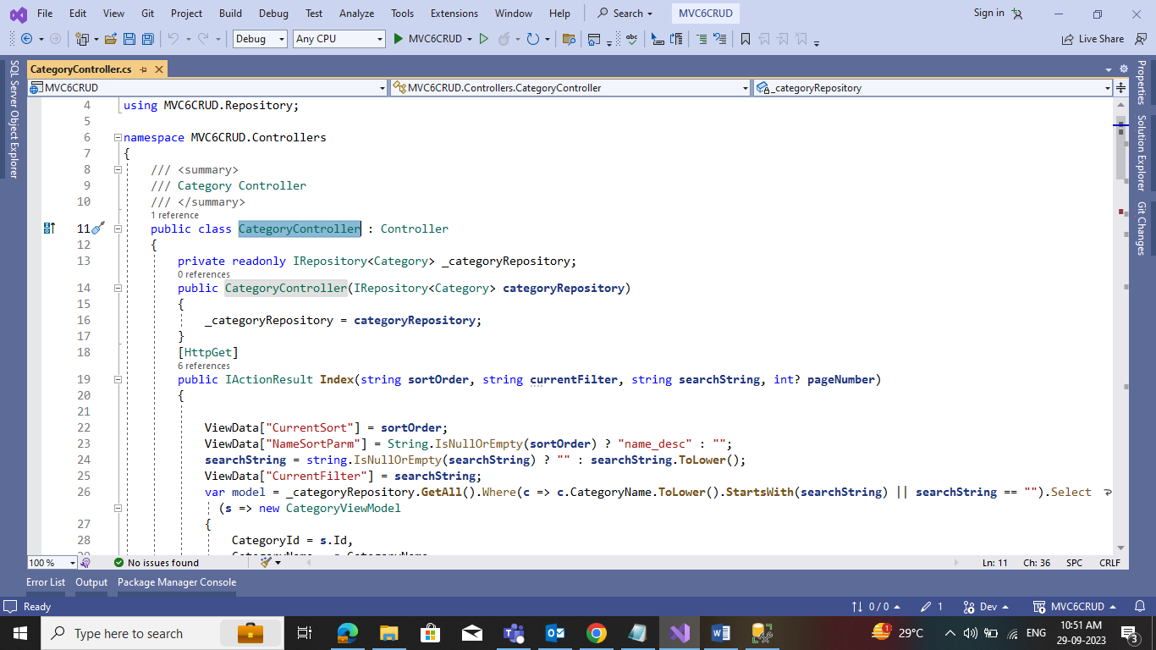

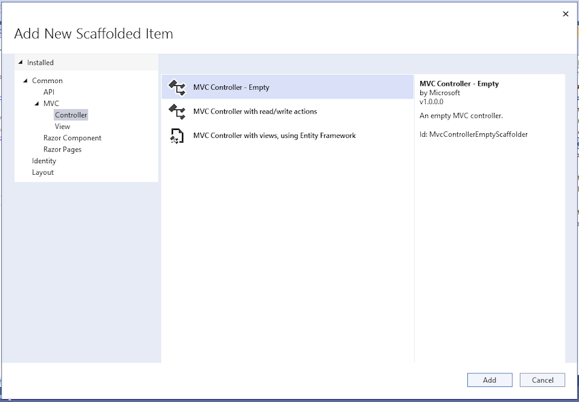

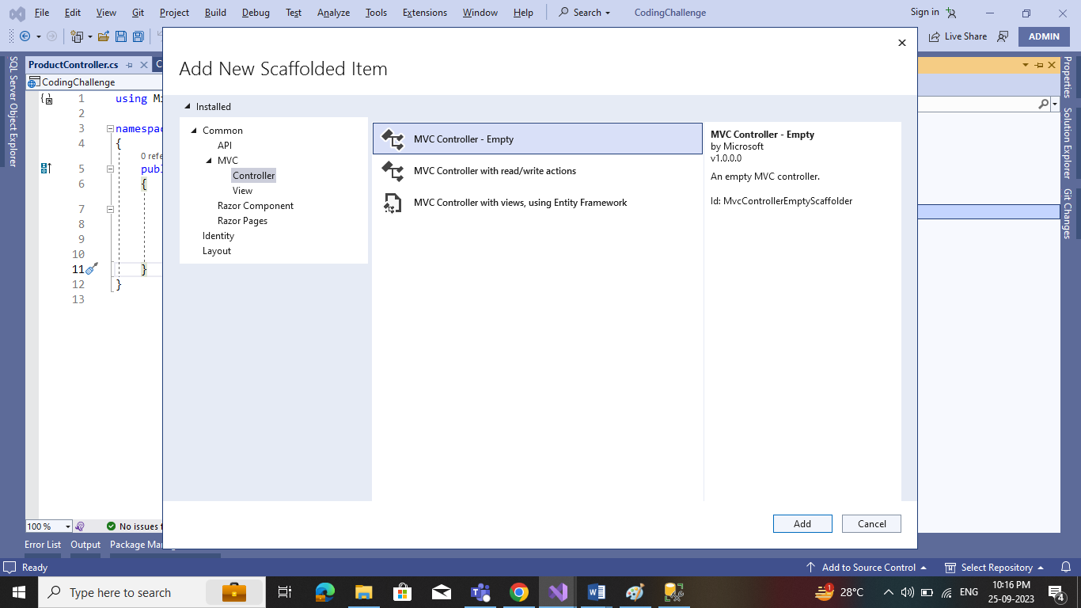

In the same way, we added a Product controller, and now both are showing in the controller folder.

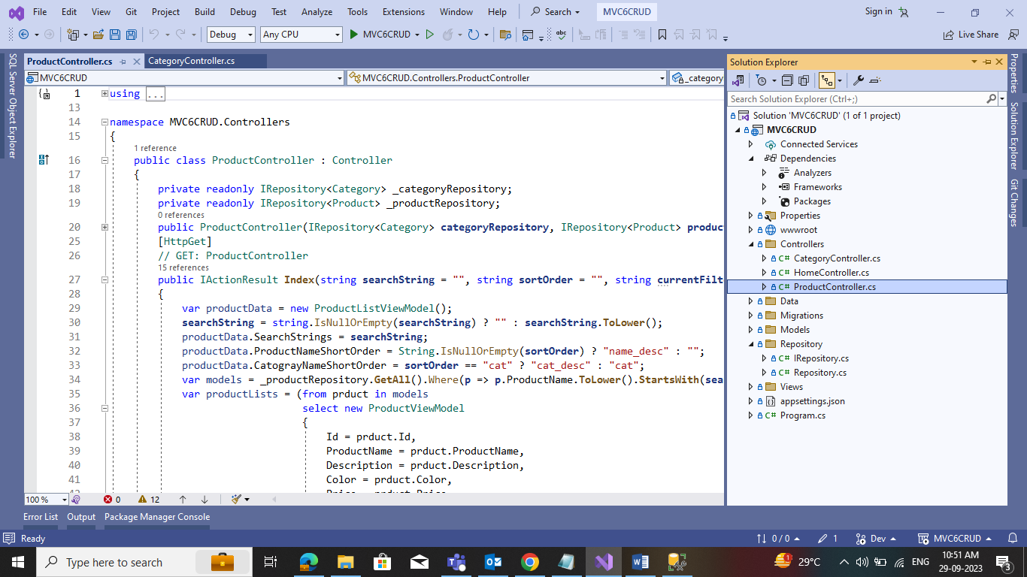

**Step 11.**Add the Category View default(Index) and Product View default(Index) in the View folder

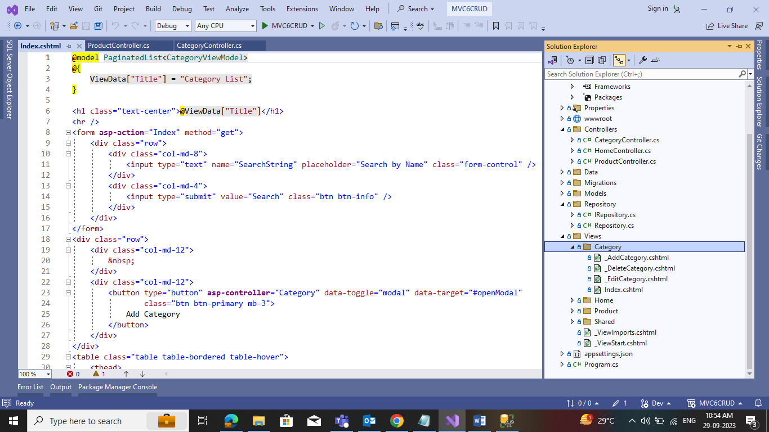

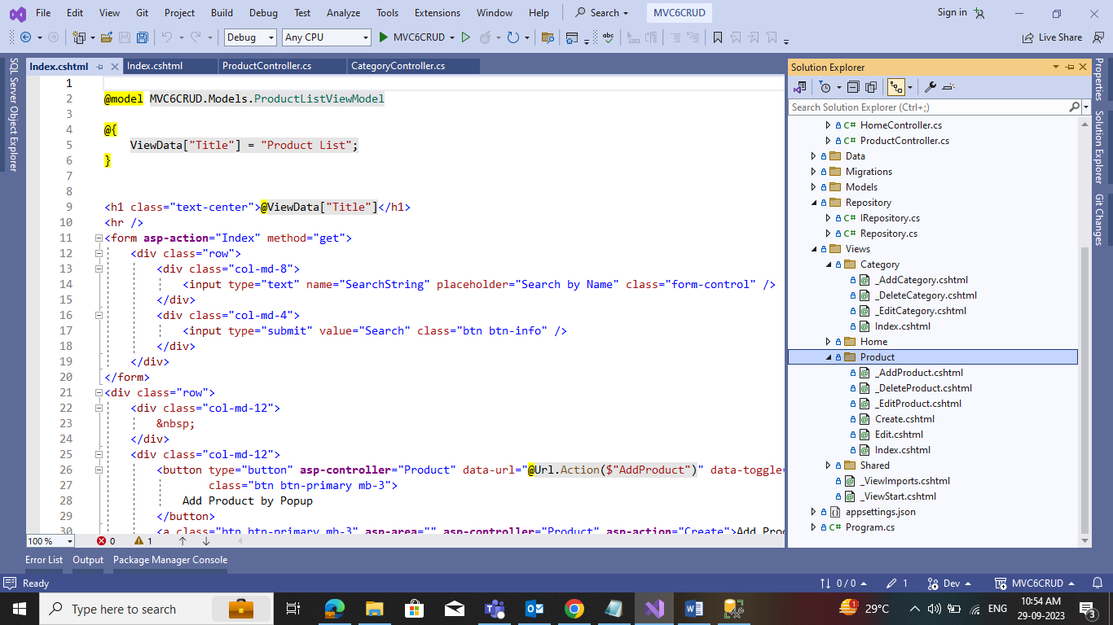

When Category View default(Index) and Product View default(Index) added then get list of Category data from database

**Step 12:** Add partial view for AddCategory and AddProduct in Category View and Product View folder **and bootstrap Model popup functionality for both partial view.**

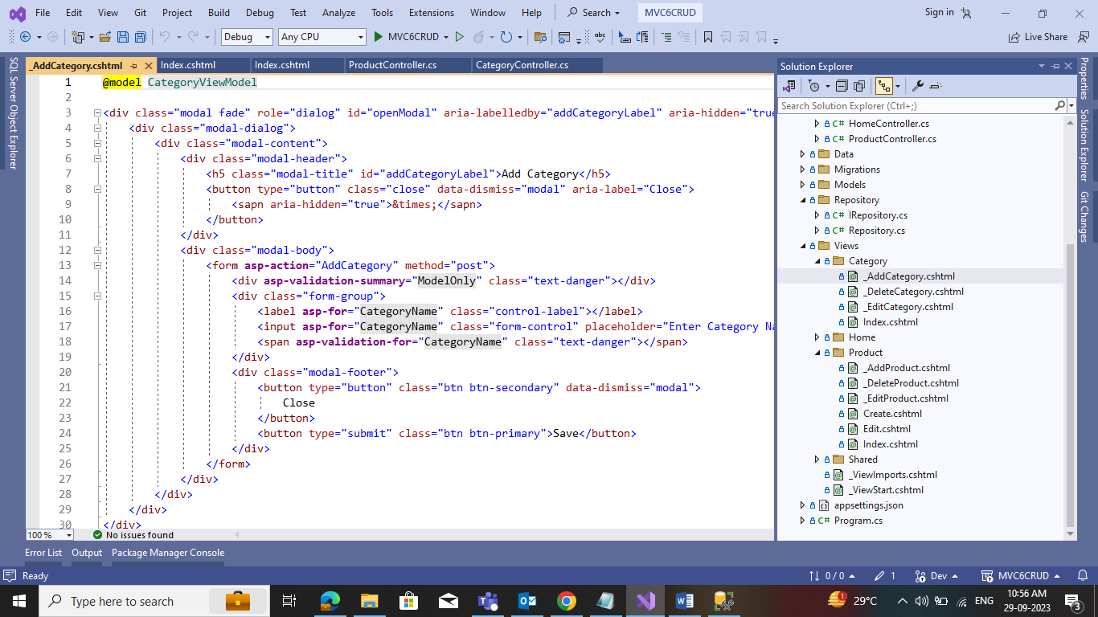

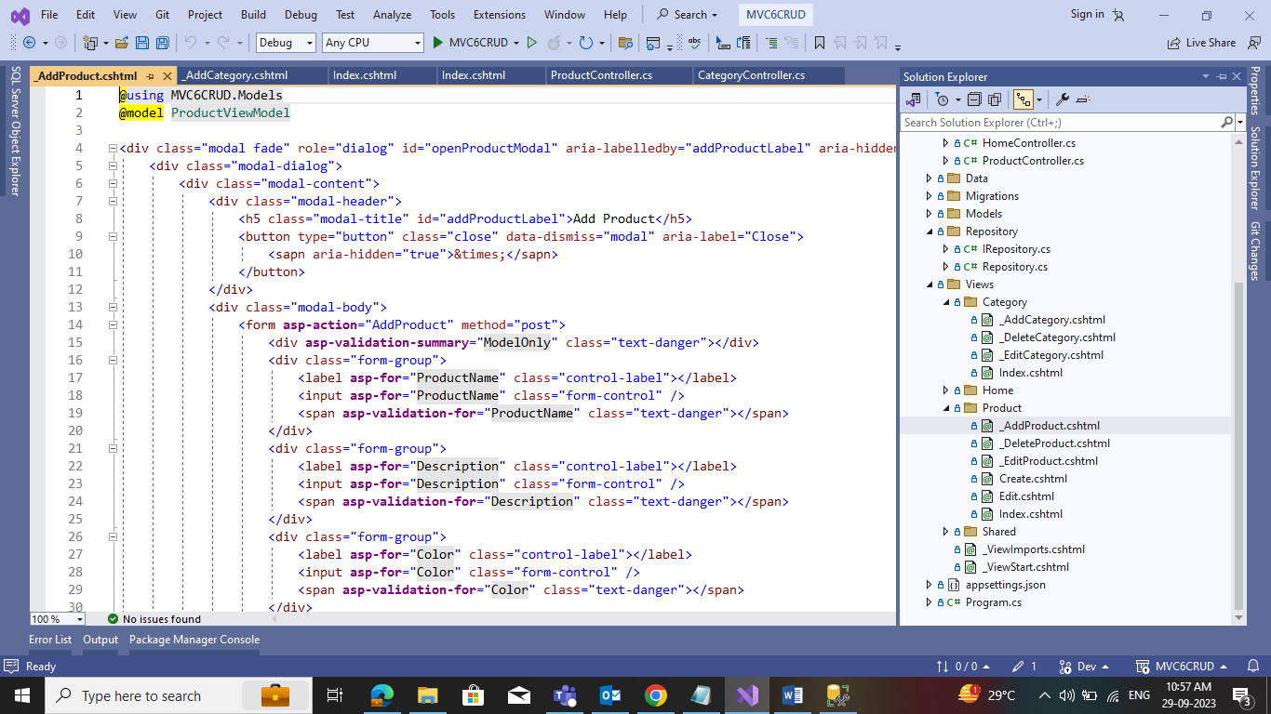

**Category CRUD operation screens**

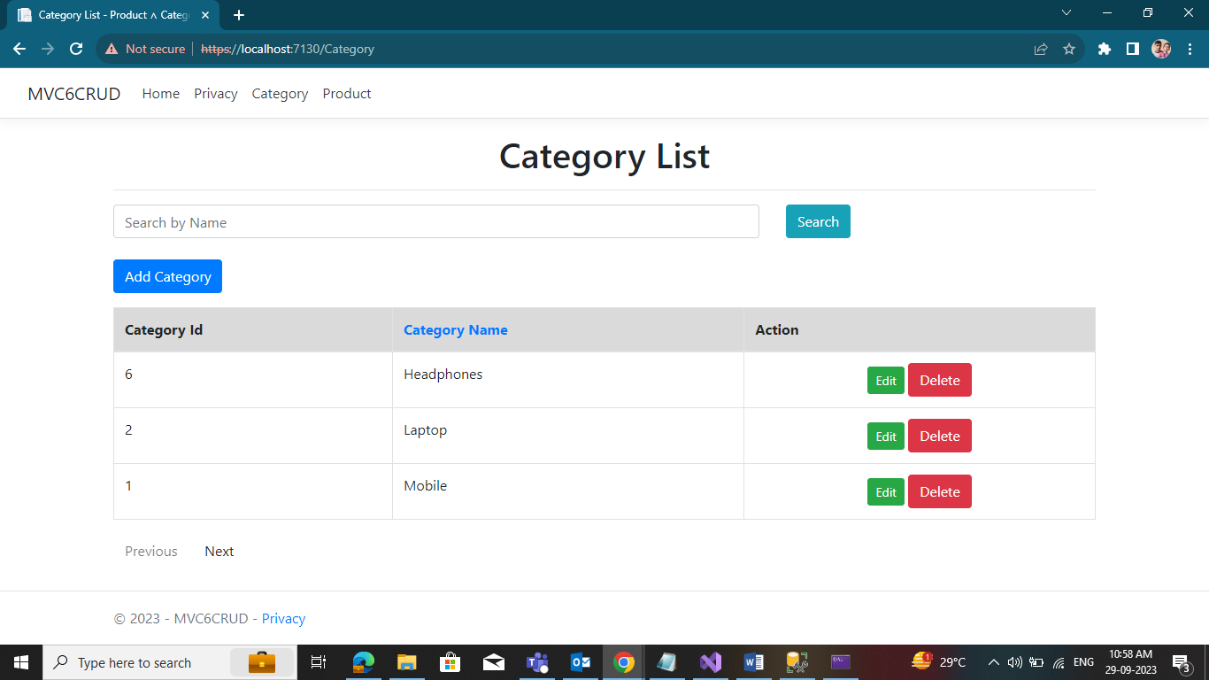

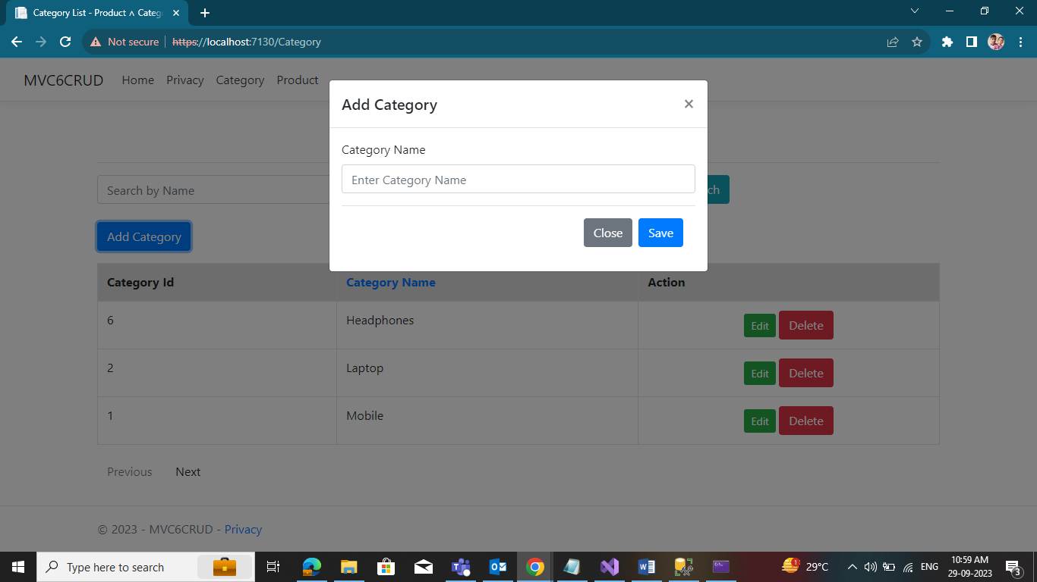

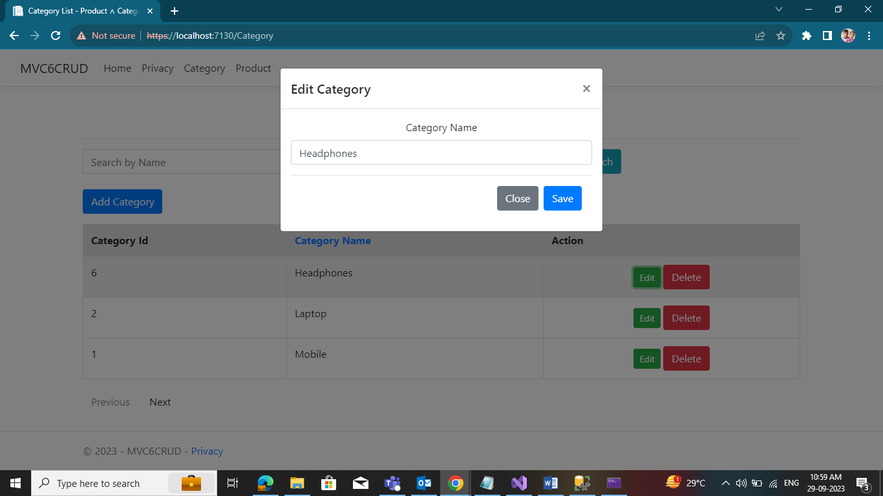

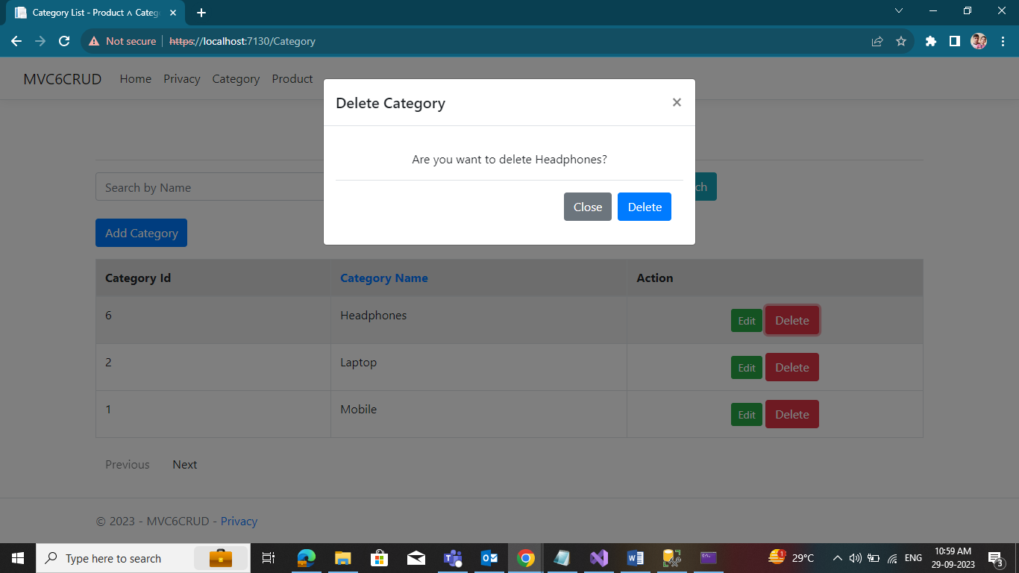

**Product CRUD operation screens**

